Karina Ivette Sánchez Barroso.
San Eustaquio No. 101, Santa Rosa, C.P. 37490
León, Guanajuato
Telephone number: 7488120
Mobile number: 4772249043
E-mail: ksanchezbarroso@gmail.com
Marital status: Single
Age: 27 years

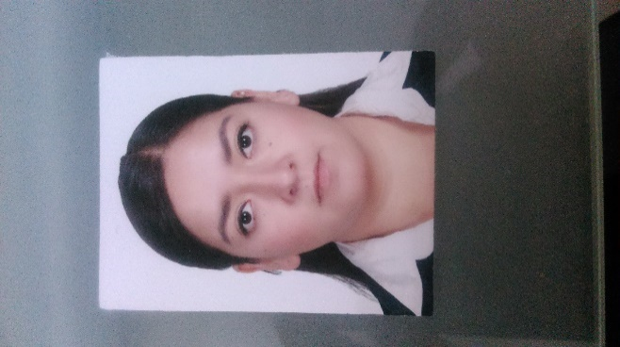

Bachelor´s Degree Sustainable Chemical Engineer

Career Summary
Sustainable Chemical Engineer with experience in teaching, professional, service performed in an engineering company as a project engineer for the pharmaceutical (Procter & Gamble) and chemical industry. Experience in galvanic processes and wastewater treatment.
Academic Training
Universidad de Guanajuato, División de Ciencias e Ingenierías, Campus León.
Degree in Sustainable Chemical Engineer
Areas: Process engineering, environmental engineering and polymers.
UG research summer in simulation.
Molecular simulation workshop taught in capital Guanajuato, from August 21th to August 25th. Molecular simulation Simposium taught in Mexico City, December 2015.
Course of implementation of the 5's
Course on the safe handling of chemical substances

Languages skills

- Native Spanish
- Enlish (Intermediate)

IT skills

Microsoft Word, Excel, PowerPoint, Visio, Autocad, AspenPlus.

Work History
Teaching. INSTITUTO ÁGUILA PREPARATORIA
January of 2011- December of 2016
High school teacher, teaching physics, chemistry, organic chemistry and mathematics.

Project Engineer. PROYECTIA, Diseño + Ingeniería
August of 2015 – August of 2016
Professional service in an engineering firm where I was part of the realization of projects for the chemical and pharmaceutical industry (Procter & Gamble). Design and calculations for chemical plants. Calculations of balances of matter and energy. I have experience in the elaboration of flow diagrams, piping and instrumentation diagrams, calculation memories, calculation of the capacities of equipment such as pumps, boilers, cooling towers, heat exchangers and calculation of flow in pipes, data sheets, equipment specification (contact with suppliers).
Chemical Process Engineer. METAL FASHION
November of 2016- December 2017
Control of the galvanizing parameters of metals for different finishes, design of processes for new finishes and wastewater treatment.
Among my tasks are the standardization and control of process parameters, research, implementation of new lines and new projects in different areas to improve quality and volumetric analysis. In this company I have been in charge of different projects. The most important was the design and construction of a water treatment train, where I was in charge of the chemical research to treat the water, then the design of the process and finally the execution of the same.

Teaching. ENMS Preparatoria Oficial de la Universidad de Guanajuato
January 2018- Now
Teaching Chemistry Laboratory
Teaching Organic Chemistry
Teaching Process separation

